The life of Moses (From Egypt to the Edge of the Promised Land)
Exodus and selected verses from Deuteronomy

LESSON 16 – The Tabernacle and the Altar of Burnt Offerings
(Exodus 26:1-27:8)

EXTRA INFO: The tabernacle was to provide a place where God might dwell among His people. The term tabernacle sometimes refers to the tent, including the Holy Place and the Most Holy Place, which was covered with embroidered curtains. But in other places it refers to the entire complex, including the curtained court in which the tent stood.
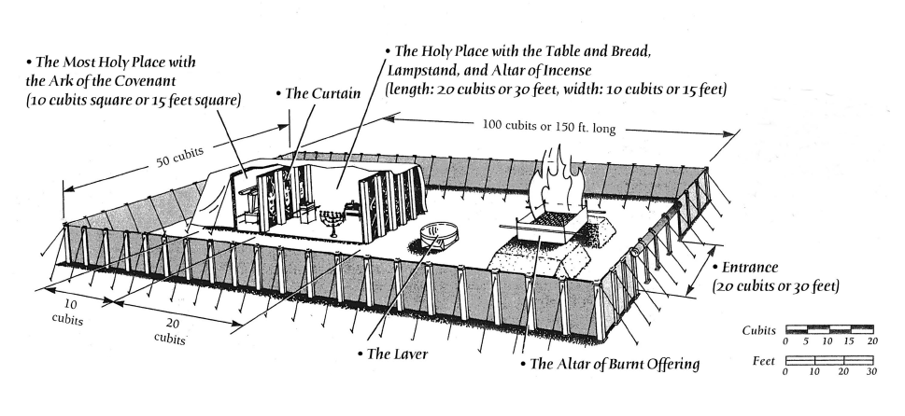
DAY ONE - Read Exodus 26:1-30 (The Tabernacle)
1. What stands out to you about the beauty of the curtains that would cover the tent of the tabernacle, as they are described in verses 1-6?
Answer here
2. What very different materials would be used as a thick outer protective covering over the first set of curtains according to verses 7-14?
Answer here
3. Briefly describe the frame or trellis work that would support the curtains and coverings.
Answer here
4. How do verses 26-29 remind us of the movability of all that would be made?
Answer here
5. Once again, how important was it for every detail of the pattern Moses was shown on the mountain to be kept?
Answer here

DAY TWO - Read Exodus 26:31-37 (The Veil and the Screen)
1. Briefly describe the veil in verses 31-33a.
Answer here
2. Then what would be brought in to stay behind the veil?
Answer here
3. What purpose, then, would the veil serve?
Answer here
4. What happened in Herod’s temple when Jesus died in Matthew 27:51 to signify there was now a new and living way into God’s presence according to Hebrews 10:19-22?
Answer here
5. Coming back to Exodus 26:36, briefly describe the screen for the door to the tent.
Answer here

DAY THREE - Read Exodus 27:1-8 (The Altar of Burnt Offerings)
1. As the altar would be made of acacia wood, what other details are given about it in verses 1-2?
Answer here
2. Why do you think this altar had to have an overlay of bronze rather than gold?
Answer here
3. What would they, also, need to make out of bronze for this altar in verse 4?
Answer here
4. What other special things would they need to do in verses 5-7?
Answer here
5. Compare verse 8 with Exodus 25:9 and 40.
Answer here

DAYS FOUR & FIVE - Read Exodus 27:9-21 (The Court of the Tabernacle and the Lampstand)
1. How would the south side of the court match the north side of the court in verses 9-11?
Answer here
2. As the gate to the court would be in the center of the entrance to the tabernacle, briefly describe that gate or screen from verse 16.
Answer here
3. Describe the similarities of all the pillars around the court in verse 17.
Answer here
4. If 20 cubits is 30 feet (1 cubit = 18 inches), translate the length, width, and height of the entire tabernacle that would block any view of the interior from the outside.
Answer here
5. What does verse 19 reiterate about all the utensils of the tabernacle for all its service, including its peg, and all the pegs of the court?
Answer here
6. What was Moses to command the children of Israel to do in verse 20?
Answer here
7. What job would be given to Aaron and his sons in verse 21a?
Answer here
8. What does verse 21b add?
Answer here
9. As the tribe of Levi was chosen by God from among the children of Israel for the priesthood, what does Numbers 3:40-41 add about them?
Answer here
10. As the lamp of the golden lampstand was to burn continuously, what does Isaiah 49:6 say about Israel being a light to the Gentiles?
Answer here

DISCUSSION: Every part of the tabernacle points to Jesus Christ Himself, especially during His time on earth and His death on the cross for our sins. Here is one example with the lampstand that was the only source of light in the Holy Place. Israel as a nation failed to be that light to the world, but thru them came the Lord Jesus Christ as the only source of light leading to salvation. Share if you like what the following verses mean to you today: John 1:9, 1:12, 9:5, and 14:6.
Answer here

