The life of Moses (From Egypt to the Edge of the Promised Land)
Exodus and selected verses from Deuteronomy

LESSON 17 – Garments for the Priesthood
(Exodus 28:1-43)

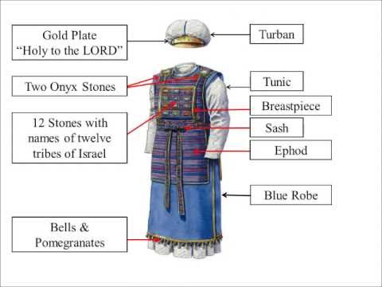

DAY ONE - Read Exodus 28:1-4 (Garments for the Priesthood)
1. Name Aaron’s sons and tell what they would be doing along with their father.
Answer here
2. Describe the garments in verse 2 that would be designed to exalt the office and function of the priesthood.
Answer here
3. Who was Moses told to find to make these garments and why would they be able to make them according to verse 3?
Answer here
4. What do these verses say about the spirit of wisdom referring to Christ, and to believers?
Isaiah 11:1-2
Answer here
Ephesians 1:17
Answer here
5. List the garments for the priesthood that would need to be made for Aaron and his sons back in Exodus 28:4.
Answer here
DAY TWO - Read Exodus 28:5-14 (The Ephod)
1. List the materials that would be necessary to begin to make the shoulder straps of the ephod according to verses 5-7.
Answer here
2. Describe the intricately woven band or girdle in verse 8.
Answer here
3. Describe what will be on each of these shoulder straps from verses 9-12 as memorial stones for the sons of Israel.
Answer here
4. What does Exodus 28:29 add about this memorial?
Answer here
5. Describe how the shoulder straps will attach to the breastplate from Exodus 28:13-14.
Answer here

DAY THREE - Read Exodus 28:15-30 (The Breastplate)
1. What is the full name of this breastplate in verse 15?
Answer here
2. As this breastplate should also be artistically woven according to the workmanship of the ephod, what stands out to you about its description in verses 16-21?
Answer here
3. How do verses 22-28 help us understand how the ephod and the breastplate would be attached to each other.
Answer here

EXTRA INFO: From this point on, the whole priestly garment can be called the ephod.

4. Again, how does verse 29 explain what it means for Aaron to be wearing these things when he goes into the Holy Place?
Answer here
5. What else was in the breastplate of judgment in verse 30, that picture Aaron’s priestly role as intercessor for the children of Israel when he goes in before the Lord?
Answer here

DAYS FOUR & FIVE - Read Exodus 28:31-36 (Other Priestly Garments)
1. Describe the robe of the ephod from verses 31-32.
Answer here
2. What is special about its hem in verse 33-34?
Answer here
3. Why would the bells be necessary according to verse 35?
Answer here
4. What very special thing was to be added to the front of the turban in verses 36-37?
Answer here
5. What does verse 38 say about what this means for Aaron?
Answer here
6. What does verse 39 say about how the tunic, the turban, and the sash should be made?
Answer here
7. What would be made for Aaron’s sons in verse 40?
Answer here
8. What should be done after Aaron and his sons were dressed in these garments according to verse 41?
Answer here
9. What else needed to be done to cover their nakedness?
Answer here
10. When would these garments need to be worn and why was it so important?
Answer here

DISCUSSION: Today as Christians, who is interceding on our behalf in heaven as our high Priest? Read Isaiah 53:12, Romans 8:34, and Hebrews 7:25.
Answer here

