The life of Moses (From Egypt to the Edge of the Promised Land)

Exodus and selected verses from Deuteronomy

**LESSON 25 – (A Jet Tour over Leviticus and Numbers)**

**DAYS ONE THRU TWO -** Read the selected verses from Leviticus to answer the questions.

**EXTRA INFO:** All ofLeviticus takes place at the foot of Sinai. This old covenant book relates to the Levites because its main concern is the service of worship at the tabernacle. The Lord gave all the laws and regulations for worship there through Moses and Aaron. The key thought in this book is holiness; the holiness of God and His people who must worship Him in holiness. Spiritual holiness was symbolized by the laws for the physical perfection of every animal who was sacrificed. Leviticus is all about substitutionary death for atonement, pointing to the perfect sacrifice of Christ. This book has all the ceremonial laws that distinguish between clean and unclean food, along with the clean an unclean physical imperfection of people who could be banished from the camp.

1. a. How was *atonement* made by transferring one’s sin to an animal before it was killed in Leviticus 1:4?

*Answer here*

b. What does Leviticus say about this in chapter 17:11?

*Answer here*

c. How does this substitutionary sacrifice prefigure the ultimate blood sacrifice made by Jesus Christ according to Hebrews 9:22?

*Answer here*

2. As chapters 1-7 show the details of all the offerings, along with the consecrated portion for Aaron and his sons, how is this section summed up in Leviticus 7:37-38?

*Answer here*

3. Chapters 8-10 concern the ministry of Aaron and his sons as priests. After Aaron presented sacrifices for himself and the people, what happened in Leviticus 9:23-24?

*Answer here*

4. a. Briefly describe what went wrong in Leviticus 10:1-3.

*Answer here*

b. What does Leviticus 10:9-11 warn against, perhaps giving us a clue for the reason Aaron’s sons committed this sin leading to death?

*Answer here*

5. As chapters 11-15 speak about the distinction between what is clean and unclean, what does Leviticus 11:44-45 say about the reason for these prohibitions?

*Answer here*

6. Give a few of examples of what stands out to you that was considered unclean from chapters 12-15.

*Answer here*

7. What had the LORD promised in Exodus 15:26 *if* the children of Israel would *heed His voice, do what is right in His sight, give ear to His commandments, and keep all His statutes*?

*Answer here*

8. As these sacrifices in Leviticus symbolize the perfect sacrifice of Christ, how will *the church be presented by Christ to Himself* according to Ephesians 5:25-27?

*Answer here*

**EXTRA INFO:** Leviticus 16 tells us about *the Day of Atonement* that came once a year when Aaron would enter *the holy place and the Holy of Holies* to spread blood on the mercy seat*.* It was seen as a covering for the sins of the nation along with individual sins. There were always many unacknowledged sins, so this special inclusive sacrifice was designed to cover all that, but only those who were genuinely faithful and repentant received its benefits.

9. Read Leviticus 16:6-28. Briefly explain how *the scapegoat* represented the substitutionary bearing and removal of sin that would later be fully accomplished by Jesus Christ.

*Answer here*

10. The end of Leviticus transitions to all the practical applications of holy conduct in society. Browse through the rest of the book and share something that stands out to you.

*Answer here*

**DAYS THREE THRU FIVE -** Read the selected verses from Numbers to answer the questions.

**EXTRA INFO:** The message here is universal and timeless, reminding believers of the spiritual warfare we are all engaged in. The theme of obedience and rebellion followed by repentance and blessing runs through the entire book as well as the entire Old Testament. This book bridges the gap between the second year when the Israelites received the law in Exodus and Leviticus in the fortieth year, preparing the next generation for the Promised Land.

1. What phrase in Numbers 1:3 and 1:24 probably explains why the census did not include women and children?

*Answer here*

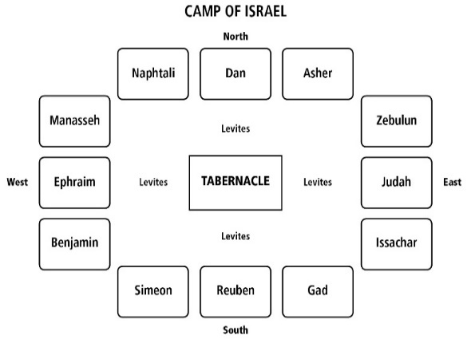2. How were the Levites separated from *the* armies

of the LORD in the camp in Numbers 2:32-34?

*Answer here*

3. As all the males from one month old and above in the priestly tribe of Levi were counted in Numbers 3, how many were there *to keep charge of the sanctuary* in Numbers 3:28?

*Answer here*

4. What did the LORD tell Moses to tell Aaron and his sons about how they should bless the children of Israel in Numbers 6:24-27?

*Answer here*

5. After keeping the Passover in the 1st month of the 2nd year, what did Moses make for himself in Numbers 10:2 *for calling and directing the movement of the camps?*

*Answer here*

6. As they left Sinai, setting out for the place the LORD promised them, what would Moses say whenever the ark set out, and whenever it rested, according to Numbers 10:35-36?

*Answer here*

7. After three days travel, list some verbs that describe some ways obedient Israel changed in Numbers 11:1-15, and how did Moses react?

*Answer here*

8. How did the LORD help Moses to *bear the burden of the people* with him in 11:16-17?

*Answer here*

9. When Miriam and Aaron spoke against Moses’ wife, questioning his authority from God, what did the LORD say about His special relationship with Moses in Numbers 12:7-8?

*Answer here*

10. When the LORD sent 12 spies into Canaan from the Wilderness of Paran at Kadesh, what report came back after 40 days from ten of those men in Numbers 13:27-28, and 32?

*Answer here*

11. Briefly describe the very different reaction that came from the other two spies, Caleb and Joshua, in Numbers 14:6-9.

*Answer here*

12. As the people complained, cried, and whined over the news from the ten, briefly describe the terrible judgment that came down from the LORD in Numbers 14:26-35.

*Answer here*

13. As the complaints of the people continued, what was Moses’ sin at Kadesh that would keep him from bringing the people into the Promised Land in Numbers 20:7-12?

*Answer here*

14. Compare Moses lifting up the bronze serpent in Numbers 21:9 with John 3:14-15?

*Answer here*

15. How did the Angel of the LORD interact with Balaam in Numbers 22:35?

*Answer here*

**DISCUSSION:** ComparewhatNumbers 32:23 says about sin with Galatians 6:7.

*Answer here*