The life of Moses (From Egypt to the Edge of the Promised Land)
Exodus and selected verses from Deuteronomy
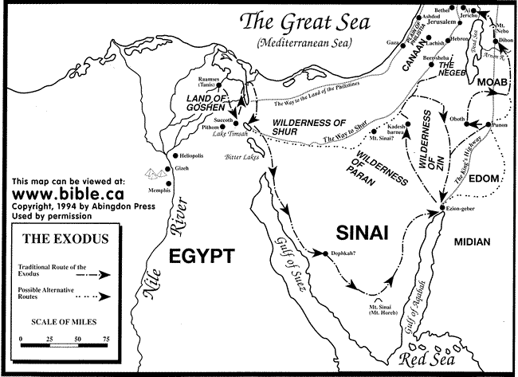

LESSON 9 – Crossing the Red Sea and the Song of Moses
(Exodus 14:13-15:21)

DAYS ONE & TWO - Read Exodus 14:16-25 (The Red Sea Crossing)
1. How was Moses now going to use the rod in verse 16 that the LORD had given him?
Answer here
2. What was the LORD going to do to Pharaoh and the Egyptians and what would be the result according to verse 17?
Answer here
3. Then what would the Egyptians know?

Answer here
4. What happened in the meantime for the protection of God’s people in verses 19-20?
Answer here
5. What happened when Moses stretched out his hand over the sea in verses 21-22?
Answer here
6. What does Psalm 66:5-6 say about what happened?
Answer here
7. How did the LORD intervene in Exodus 14:24-25 when the Egyptians pursued and went after them into the midst of the sea with Pharaoh’s horses, chariots, and horsemen?
Answer here
8. What happened when Moses obeyed the LORD the next morning by stretching out his hand over the sea once more, after the children of Israel were safe on the other side?
Answer here
9. How does verse 29 describe how the children of Israel went safely through the sea?
Answer here
10. As the LORD saved Israel that day out of the hand of the Egyptians, what did Israel see and what was the result?
Answer here

DAYS THREE THRU FIVE - Read Exodus 15:1-21 (The Song of Moses)
1. Give the reasons Moses and the children of Israel are singing this song to the LORD according to verses 1-2.
Answer here
2. What stands out to you in verses 3-7 that help us see that the LORD is a man of war?
Answer here
3. How does Psalm 78:13 confirm Exodus 15:8?
Answer here
4. How is the enemy portrayed as helpless against the power of the LORD in Exodus 15:9-10?
Answer here
5. What is the question in verse 11?
Answer here
6. How does Deuteronomy 3:24 ask the same question?
Answer here
7. How is this victory described in Exodus 15:12?
Answer here
8. What had God done in His mercy in verse 13?
Answer here
9. What do the following verses say about God’s holy habitation?
Exodus 15:17
Answer here
Deuteronomy 12:5
Answer here
Psalm 78:54
Answer here
10. a. List the places in Exodus 15:14-15 where the children of Israel will pass over in the future.
Answer here
b. List the words that describe how these different peoples in verses 14-16 will react knowing what the LORD had done for His people, till they passed by.
Answer here
11. How do the following examples show this great fear of Israel as they head toward and enter their Promised Land?
Exodus 23:27-28
Answer here
Deuteronomy 2:25
Answer here
Joshua 2:9-11
Answer here
12. Briefly tell how Exodus 15:17 is an expression of confidence in the promises that God had made to Abraham 700 years earlier in Genesis 12, 15, and 17.
Answer here
13. Compare Exodus 15:18 with Psalm 145:13.
Answer here
14. How does verse 19 summarize what just happened?
Answer here
15. As Aaron’s sister Miriam was given the honor of being called a prophetess how did she and all the women with her celebrate what the LORD had done for them?
Answer here

DISCUSSION: The children of Israel have just been delivered from the bondage of slavery by the Egyptians. Today, what kind of bondage have New Testament believers been delivered from? Read Romans 8:15-17, Hebrews 2:14-15, and 1 John 4:18-19.
Answer here

